STUDENT MANAGEMENT SYSTEM

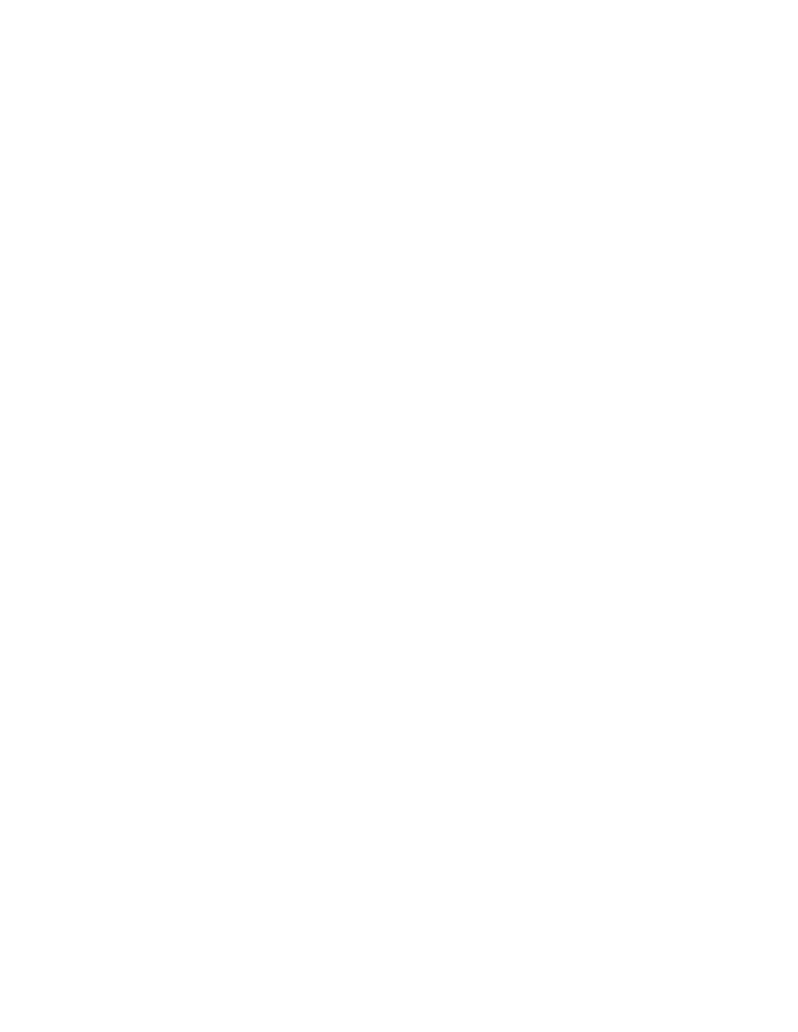

20K-1081

20K-1075

20K-0409



27/03/2021

**─**

Team:

Bahadur Khan

Sumsam Ali

Mukand Krishna

1



Overview

This project is about the problem of management of Students, which needs to be more eﬃcient. It would deal with the management of data of Students and also Teachers, which is also necessary. It would be based on the Object Oriented Paradigm.

Problem Statement

Most of the schools do not have automated systems for managing their data of students, teachers and also administrators. It is better for the schools and universities to have software based management software.

Solution

Our solution is simple. It would allow the universities and schools to manage their data more eﬃciently with the help of software. It would be fully automated and that would make it easy to use. Our main focus would be eﬃciency and implementing an Object oriented way of programming.

Goals

1. Add Student

2. Remove Student

3. Modifying Data

4. Login Logout System

5. Show Data

6. Search Student

7. Grading

8. Add Teacher

9. Remove Teacher

10. Marking of Students

11. GPA Calculations

12. Any related functionality would be added if time permits.

2



Speciﬁcations

This project will be based on an object oriented way of programming which is the standard of all big tech companies nowadays. As it is also the requirement of our course, it would also enhance our understanding of the OOP.

Data Storage:

For storing the data of all objects representing real world entities involving Student management systems, we would use Filing in C++.

Object Oriented Paradigm:

It is a very essential part of the solution that we are going to build for the above stated problem statement. It is basically a go to standard for all the companies nowadays and that would make our software up to the mark.

Modules

I. Administrator:

It would be a class providing the functionality of the Admin. The Administrator will be responsible for all the management tasks which are faced by any manual system. The Administrator will be able to add, modify and remove students and change anything according to the privileges.

II. Student:

This class will be responsible for all the functionalities related to the Student. The Student class will represent the Students as an object of the real world. It would help in simulating all the real life scenarios involving Students.

III. Teacher:

This class will be responsible for grading and attendance of the student objects. It will represent the objects of the Teacher. It would also include methods such as assigning assignments to the students.

3



**NOTE**: If Time permits, we would also try to implement Graphical user Interface for better appeal of the project.

**THANK YOU**

**Regards.**